Task 3 in asana

Comparing distribution of response code’s by conversion and ga add to cart.

Insights:

1. If color question is the one before last question, there is a smaller chance for a conversion. And it is the other way around regarding ga_add_to_cart, which is weird.

One before last nbr (the one that was answered or ignored)

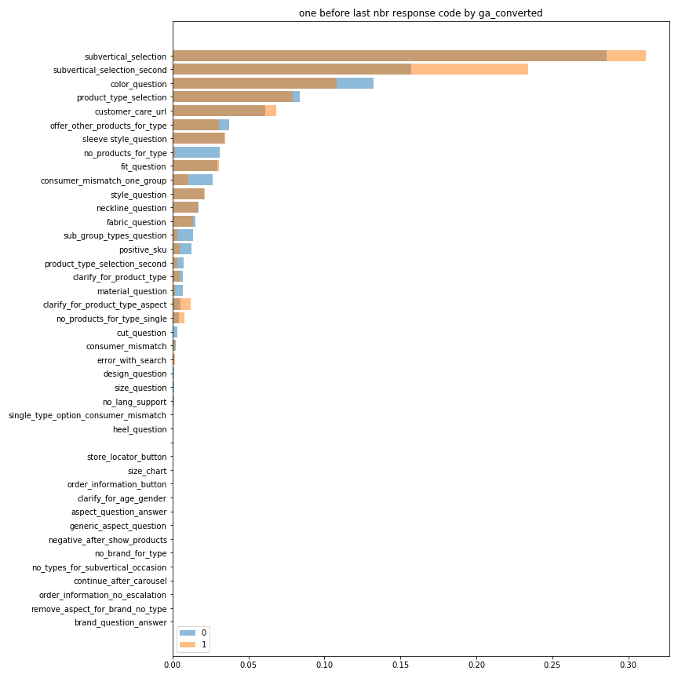

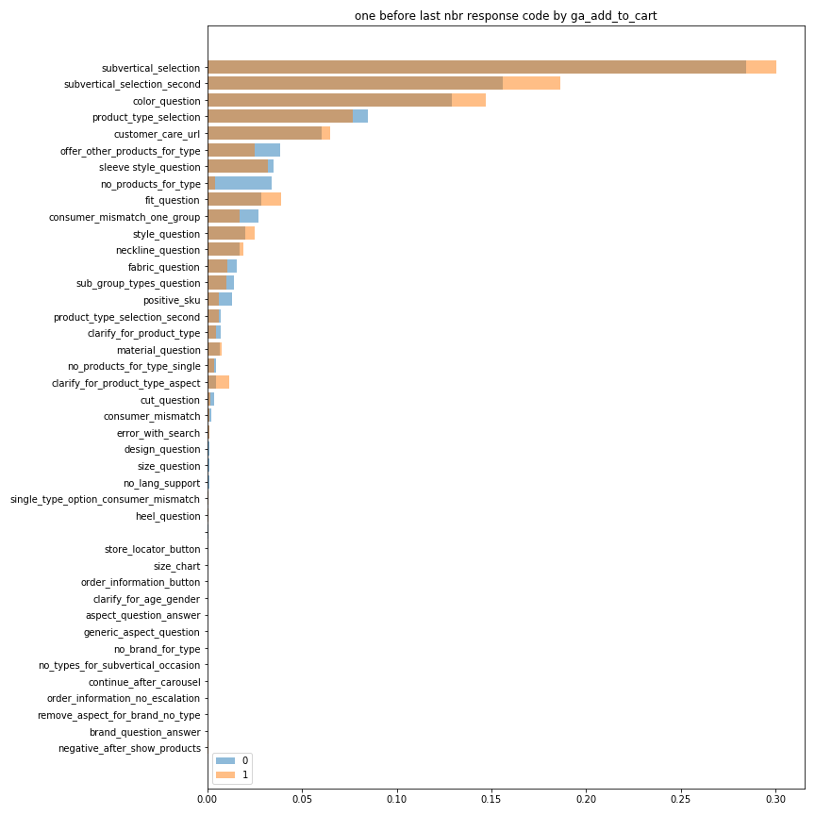

Last nbr (the one that was ignored) 